vSphere ESXi 6.5 Automated UNMAP with Hitachi VSP G/F Storage
Introduction - In vSphere 6.5, there is now an automated UNMAP crawler mechanism for reclaiming dead or
stranded space on VMFS datastores. This automatically reclaims stranded space due to 1) VM deletions or Storage vMotions or 2) In-Guest OS data deletions. Prior to vSphere 6.5, these were manual operations for administrators.
Additional Background: Check UNMAP section @ https://storagehub.vmware.com/export_to_pdf/vsphere-6-5-storage
Key Dependencies
- Use Thin provisioned VMDKs/RDMs back with thin provisioned LDEVs/LUs
- For Linux guest OS, use hardware version 13 or later to present SCSI-4
- For Windows 2012R2 OS, hardware version 1 or higher is fine
- VMFS 6 datastores
- vSphere ESXi 6.5 (VMware ESXi 6.5.0 build-4564106 used internally)
- Storage: VSP G/F1x000 ( T-code Microcode: 80-05-46-00/80.)
Sections:
- Initial Setup for Automated UNMAP on VSP G/F Storage
- TWO USE CASES for Automated UNMAP
  - Observe automatic space reclaim after In-guest OS data deletion
  - Observe automatic space reclaim after VM deletion
- FAQ
- Appendix for Support

- Initial Setup for Automated UNMAP on VSP G/F Storage

- Enable Active UNMAP
(ii) Set HMO63 to activate UNMAP.
(iii) Set SOM847 to ON.
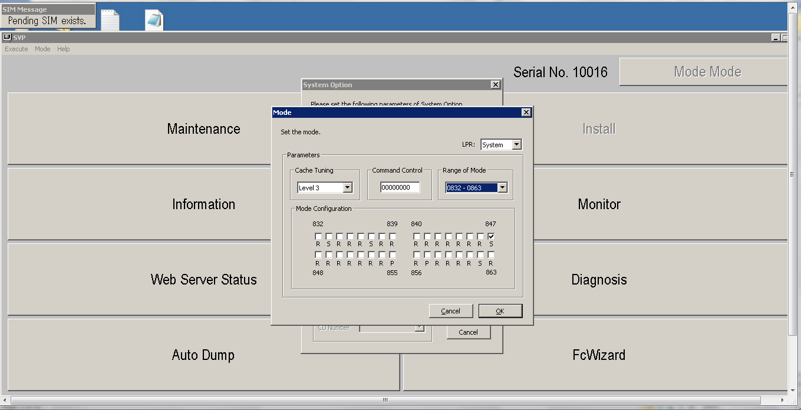
(iv) Set HMO114 to ON.
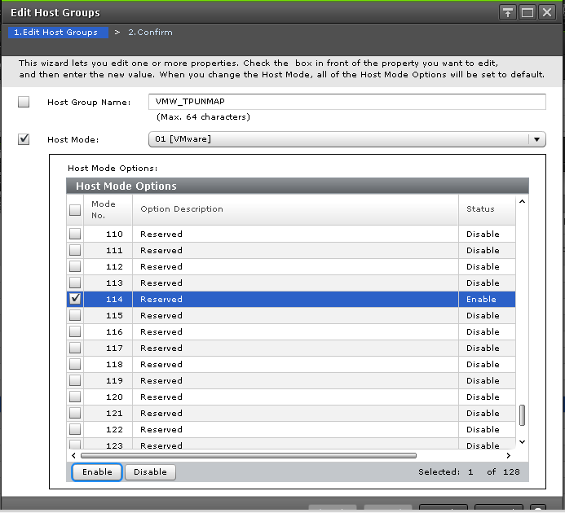
(v) Set SOM847 to OFF.

- “Rescan all” is performed on vmhbas <
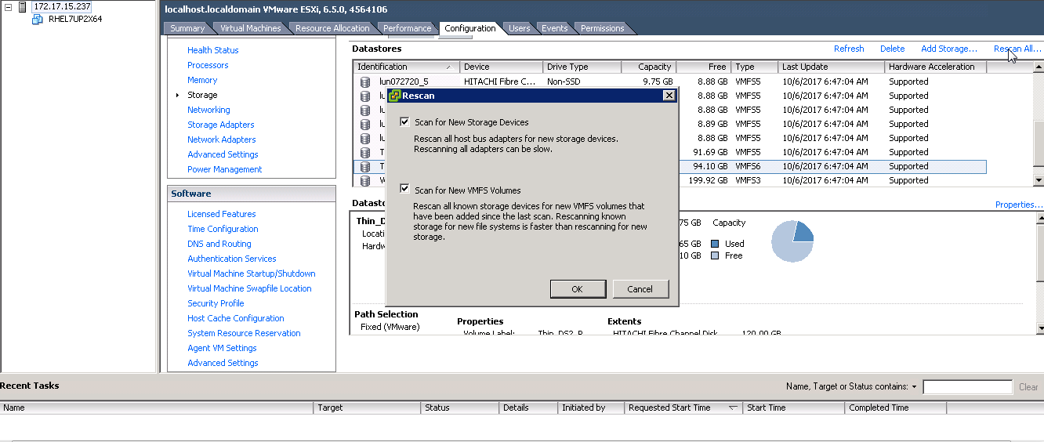

- Optional , Execute the command
“vsish -e cat /storage/scsifw/devices/naa.60060e80072720000030272000000032/inquiryVPD/176/data” to check that inquiry data from VSP G is reporting 256KB UNMAP Granularity (
i.e Byte 28-31 shows changed values after rescan and with HMO 114 enabled.
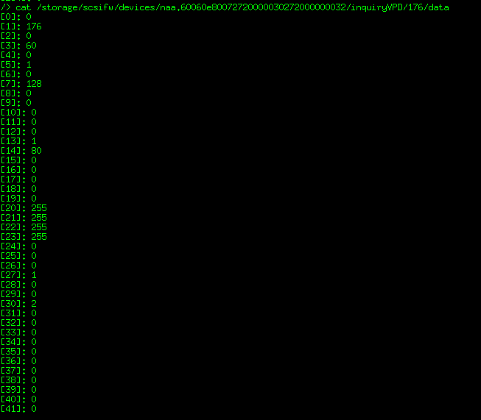

Use Case 1: Observe automatic space reclaim after VM deletion
Sample Test Setup Details:
1) Deploy a VM on a VMFS6 datastore
(internal test :- Datastore: VM “W2K8R2X64” created on Thin_DS2_R800 (VMFS6) datastore; VMDK size in test case was 100+GB)
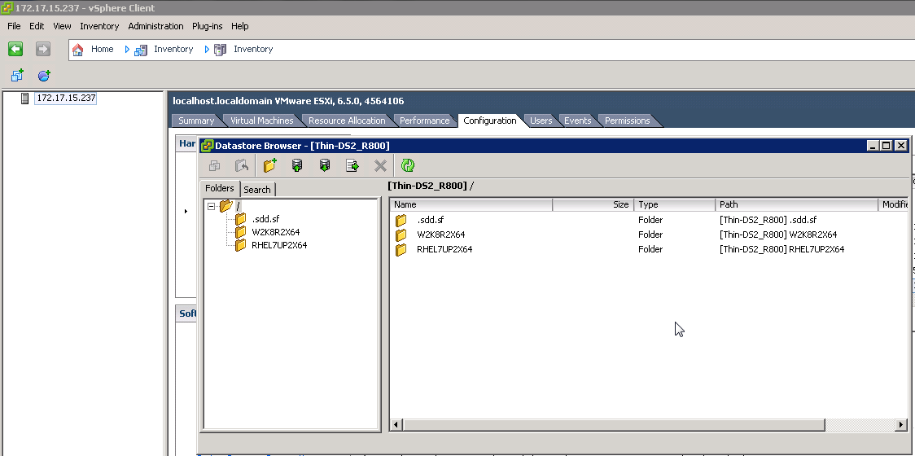
Example: Virtual Volume”00:32” is volume behind the Thin_DS2_R800 datastore
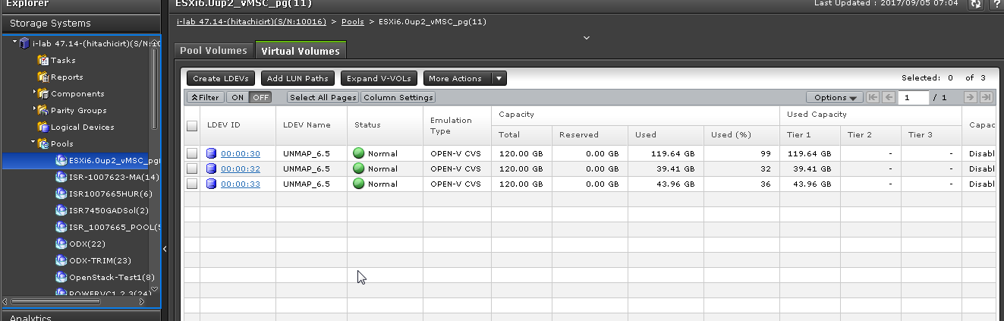
- Delete the VM
VM “W2K8R2X64” on Thin_DS2_R800 is deleted:
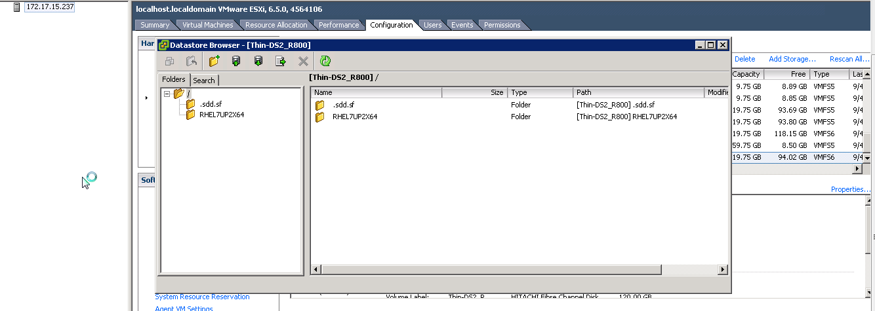

- Check if a pool capacity was decreased, Pool capacity decrease time varies from 30 mins to 1 hour [Note, we have seen instances where ESXi hosts can take up to 24 hours or more and working with VMware to understand instances for that behavior]

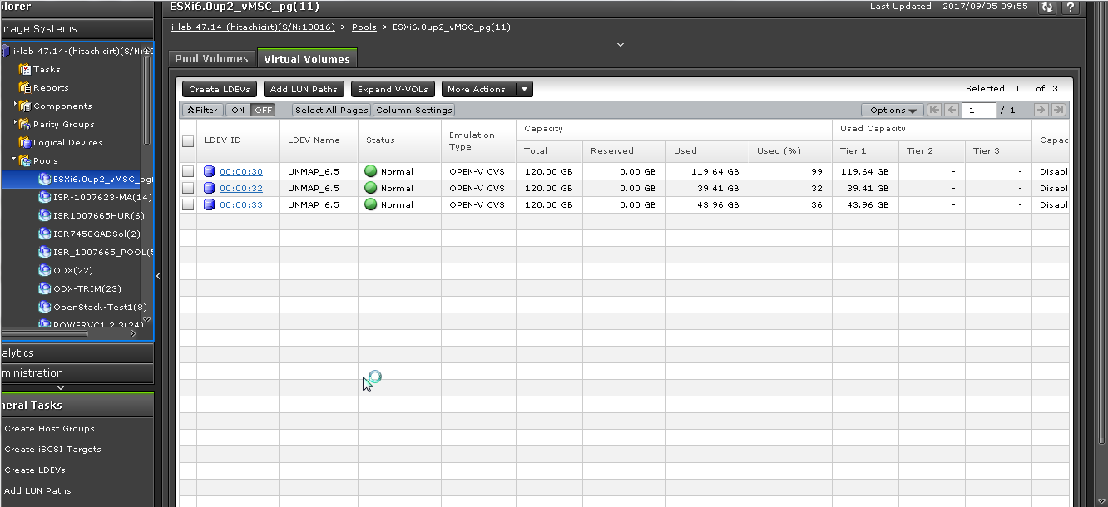

Use case 2: Observe automatic space reclaim after In-guest OS data deletion
Sample Test Setup Details:

- Deploy a VM RHEL 7.2 VM is copied on this Datastore.
(internal test :- VM-> RHEL 7.2 with 2 disks, HW version-13, ext4 filesystem mounted in Linux with –discard option
- virtual disk 2, presented as /dev/sdb -> 100G thin vmdk from a thin 120G LU datastore.
- virtual disk 3, /dev/sdc -> 120G RDM added to VM.
#mkfs.ext4 /dev/sdb1
#mount /dev/sdb1 /u02 -o discard
(both the datastores are on thin LUs)

- Delete 1GB file from within Guest OS on both disks

Sample outputs from internal tests

Before delete of file:

- Optional VMware script to check # of UNMAP I/Os

[root@localhost:~] vsish /> get /vmkModules/vmfs3/auto_unmap/volumes/Thin_DS2_R800/properties
Volume specific unmap information {
Volume Name :Thin_DS2_R800
FS Major Version :24
Metadata Alignment :4096
Allocation Unit/Blocksize :1048576
Unmap granularity in File :1048576
Volume: Unmap IOs :6
Volume: Unmapped blocks :324
Volume: Num wait cycles :0
Volume: Num from scanning :6
Volume: Num from heap pool :5
Volume: Total num cycles :57

- Check Capacity on datastore

[root@localhost:~] vmkfstools -Ph -v 1 /vmfs/volumes/Thin_DS2_R800/
VMFS-6.81 (Raw Major Version: 24) file system spanning 1 partitions.
File system label (if any): Thin_DS2_R800
Mode: public ATS-only
Capacity 119.8 GB, 93.1 GB available, file block size 1 MB, max supported file size 64 TB
Volume Creation Time: Sun Jan 14 21:47:26 2001
Files (max/free): 16384/16371
Ptr Blocks (max/free): 0/0
Sub Blocks (max/free): 16384/16363
Secondary Ptr Blocks (max/free): 256/255
File Blocks (overcommit/used/overcommit %): 0/27316/0
Ptr Blocks (overcommit/used/overcommit %): 0/0/0
Sub Blocks (overcommit/used/overcommit %): 0/21/0
Large File Blocks (total/used/file block clusters): 240/0/240
Volume Metadata size: 1504247808
UUID: 3a621e6e-1f3492e8-29a5-6cc2172acba0
Partitions spanned (on "lvm"):
naa.60060e80072720000030272000000032:1
Is Native Snapshot Capable: NO
346292:VVOLLIB : VVolLibTracingExit:150: Successfully cleaned up the VVolLib tracing module
OBJLIB-LIB: ObjLib cleanup done.
WORKER: asyncOps=0 maxActiveOps=0 maxPending=0 maxCompleted=0

- Check Capacity in Linux VM

[root@localhost ~]# df -h
Filesystem Size Used Avail Use% Mounted on
/dev/mapper/rhel-root 23G 3.5G 19G 16% /
devtmpfs 910M 0 910M 0% /dev
tmpfs 921M 0 921M 0% /dev/shm
tmpfs 921M 8.5M 912M 1% /run
tmpfs 921M 0 921M 0% /sys/fs/cgroup
/dev/sda1 497M 125M 373M 25% /boot
tmpfs 185M 0 185M 0% /run/user/0
/dev/sdb1 99G 1.1G 93G 2% /disk1
/dev/sdc1 118G 1.1G 111G 1% /disk2

- Delete files in guest OS

[root@localhost ~]# rm /disk2/test2.zip
rm: remove regular file â€˜/disk2/test2.zipâ€™? y
[root@localhost ~]# rm /disk1/test1.zip
rm: remove regular file â€˜/disk1/test1.zipâ€™? y
[root@localhost ~]#

After delete of file:
- Optional: to check # of UNMAP I/Os

[root@localhost:~] vsish /> get /vmkModules/vmfs3/auto_unmap/volumes/Thin_DS2_R800/properties
Volume specific unmap information {
Volume Name :Thin_DS2_R800
FS Major Version :24
Metadata Alignment :4096
Allocation Unit/Blocksize :1048576
Unmap granularity in File :1048576
Volume: Unmap IOs :20
Volume: Unmapped blocks :1187
Volume: Num wait cycles :0
Volume: Num from scanning :7
Volume: Num from heap pool :8
Volume: Total num cycles :68
}

- Check Capacity on datastore

[root@localhost:~] vmkfstools -Ph -v 1 /vmfs/volumes/Thin_DS2_R800/
VMFS-6.81 (Raw Major Version: 24) file system spanning 1 partitions.
File system label (if any): Thin_DS2_R800
Mode: public ATS-only
Capacity 119.8 GB, 94.1 GB available, file block size 1 MB, max supported file size 64 TB
Volume Creation Time: Sun Jan 14 21:47:26 2001
Files (max/free): 16384/16371
Ptr Blocks (max/free): 0/0
Sub Blocks (max/free): 16384/16363
Secondary Ptr Blocks (max/free): 256/255
File Blocks (overcommit/used/overcommit %): 0/26268/0
Ptr Blocks (overcommit/used/overcommit %): 0/0/0
Sub Blocks (overcommit/used/overcommit %): 0/21/0
Large File Blocks (total/used/file block clusters): 240/0/240
Volume Metadata size: 1504247808
UUID: 3a621e6e-1f3492e8-29a5-6cc2172acba0
Partitions spanned (on "lvm"):
naa.60060e80072720000030272000000032:1
Is Native Snapshot Capable: NO
346339:VVOLLIB : VVolLibTracingExit:150: Successfully cleaned up the VVolLib tracing module
OBJLIB-LIB: ObjLib cleanup done.
WORKER: asyncOps=0 maxActiveOps=0 maxPending=0 maxCompleted=0

- Check Capacity in Linux VM

[root@localhost ~]# df -h
Filesystem Size Used Avail Use% Mounted on
/dev/mapper/rhel-root 23G 3.5G 19G 16% /
devtmpfs 910M 0 910M 0% /dev
tmpfs 921M 0 921M 0% /dev/shm
tmpfs 921M 8.5M 912M 1% /run
tmpfs 921M 0 921M 0% /sys/fs/cgroup
/dev/sda1 497M 125M 373M 25% /boot
tmpfs 185M 0 185M 0% /run/user/0
/dev/sdb1 99G 61M 94G 1% /disk1
/dev/sdc1 118G 61M 112G 1% /disk2

FAQ

- When a VM-OS or ESX host do an unmap. will the box do a reclaim immediately or time scheduled (?? time)?
[pm] ESXi 6.5 host will issue the unmap asynchronously to the storage array. The space reclamation operates in the background on ESXi host (like a crawler process) and it frequency is based priority levels set per individual VMFS datastores. From the initial set of tests we have done, we have seen UNMAP being issued from ESXi anywhere from 30 seconds to 60 minutes after in-guest VM data deletion and sometimes longer (3+hours) for VM/virtual disk migration/deletion. The Hitachi Storage array will process that request so space reclamation completion time depends on resources available to process the request. VMware Engineering have acknowledged they are starting off conservatively but we are engaged with them to find a more dynamic approach in future release for those customers who may need a faster space reclaimation.
- Reclaim is a background process, are there impact counters available (CPU/IOPS/xFer/FEP) or best practices?
[pm] There are unmap counters with commands like esxtop and more with “vsish”, a VMware support tool script. We are formulating some best practices and guidance as we review the initial set of tests but with ESXi being conservative, (25MB/sec), there should be no impact.
- Will reclaiming data stops or postponed when there is less ?? MP utilization available for that disk?
[pm] The process is treated as a lower class service to avoid impact to production I/O services. The data rate from ESXi is conservative so no contention problem for Hitachi VSP class storage
- An unmap command from ESX/VM for 10 pages, will this xFer 420MB (10 x 42MB page) of data over the SAN link or just 1 VAAI command for reclaim the 10 pages?
[pm] ESXi will send LBA range, not the actual page data. ESXi will issue unmap requests in increments on 1MB and multiples of 1MB. Hitachi VSP can do unmap as granular as 256KB. [Need to confirm if one/more requests for large block sizes but I believe one unmap command includes as much dead space reclaimation that crawler observed..I will verify this ]
- Follow up on the above question: When a datastore is replicated, will all reclaimed data sync or just the VAAI command to svol side and also reclaimed at the svol side?
[pm] Reclamation process zeros out the data which would get replicated/deduped but let me get consensus data with an engineering test with auto unmap
- With VVOL configuration, you create larger disks, is there a different (unmap) impact compare with the VMFS datastores?
[pm] With VVol , there is no UNMAP for activities like VM vMotion or VM / virtual disk deletion which would normally leave unreclaimed spece in a datastore. For VVol, each vmdk is its own mini-LUN so no space reclamation needed. For in-guest VM data deletion, it would behave the same as VMFS6 but we have not done that specific test yet.
- You can set discard or use fstrim in Linux, are there best practices? I suppose when you deleting and recreate data constantly it is useless to set an unmap option, but maybe also other combinations?
[pm] I’m working with VMware to help capture some of these best practices. I hope to publish a blog on the topic but will share when I have draft content from VMware. We’ve used the –discard option in our internal tests.

Appendix

Troubleshooting – Example outputs

vdisk2 (/dev/sdb) – virtual disk from Thin LU

[root@localhost ~]# sg_vpd --page=0xb0 /dev/sdb -vvv
open /dev/sdb with flags=0x800
inquiry cdb: 12 01 b0 00 fc 00
duration=0 ms
Block limits VPD page (SBC):
[PQual=0 Peripheral device type: disk]
Write same no zero (WSNZ): 0
Maximum compare and write length: 0 blocks
Optimal transfer length granularity: 0 blocks
Maximum transfer length: 0 blocks
Optimal transfer length: 0 blocks
Maximum prefetch length: 0 blocks
Maximum unmap LBA count: 65536
Maximum unmap block descriptor count: 64
Optimal unmap granularity: 2048
Unmap granularity alignment valid: 1
Unmap granularity alignment: 0
Maximum write same length: 0x0 blocks
[root@localhost ~]#
[root@localhost ~]#
[

[root@localhost ~]# sg_vpd --page=0xb2 /dev/sdb -vvv
open /dev/sdb with flags=0x800
inquiry cdb: 12 01 b2 00 fc 00
duration=0 ms
Logical block provisioning VPD page (SBC):
[PQual=0 Peripheral device type: disk]
Unmap command supported (LBPU): 1
Write same (16) with unmap bit supported (LBWS): 0
Write same (10) with unmap bit supported (LBWS10): 0
Logical block provisioning read zeros (LBPRZ): 1
Anchored LBAs supported (ANC_SUP): 0
Threshold exponent: 1
Descriptor present (DP): 0
Provisioning type: 2

vdisk3 (/dev/sdc) - RDM

[root@localhost ~]# sg_vpd --page=0xb0 /dev/sdc -vvv
open /dev/sdc with flags=0x800
inquiry cdb: 12 01 b0 00 fc 00
duration=0 ms
Block limits VPD page (SBC):
[PQual=0 Peripheral device type: disk]
Write same no zero (WSNZ): 0
Maximum compare and write length: 1 blocks
Optimal transfer length granularity: 128 blocks
Maximum transfer length: 0 blocks
Optimal transfer length: 86016 blocks
Maximum prefetch length: 0 blocks
Maximum unmap LBA count: 4294967295
Maximum unmap block descriptor count: 1
Optimal unmap granularity: 512
Unmap granularity alignment valid: 0
Unmap granularity alignment: 0
Maximum write same length: 0x0 blocks
[root@localhost ~]#

- Execute the following command to check an inquiry data.
vsish -e cat /storage/scsifw/devices/naa.60060e80072720000030272000000032/inquiryVPD/176/data

